1. **Write a Python Program to Add Two Matrices?**

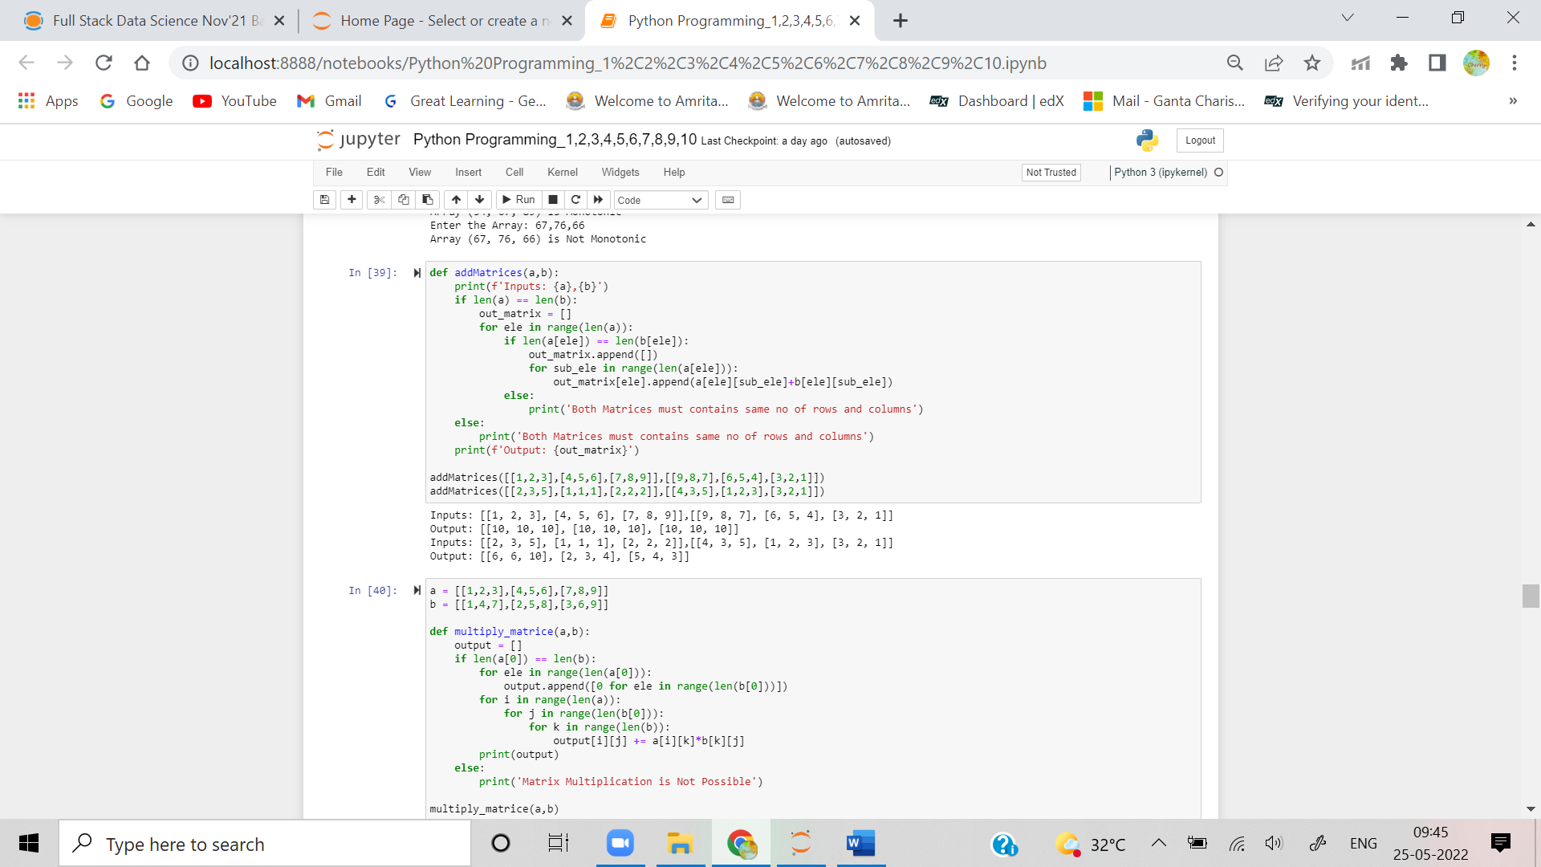

1. **Write a Python Program to Multiply Two Matrices?**

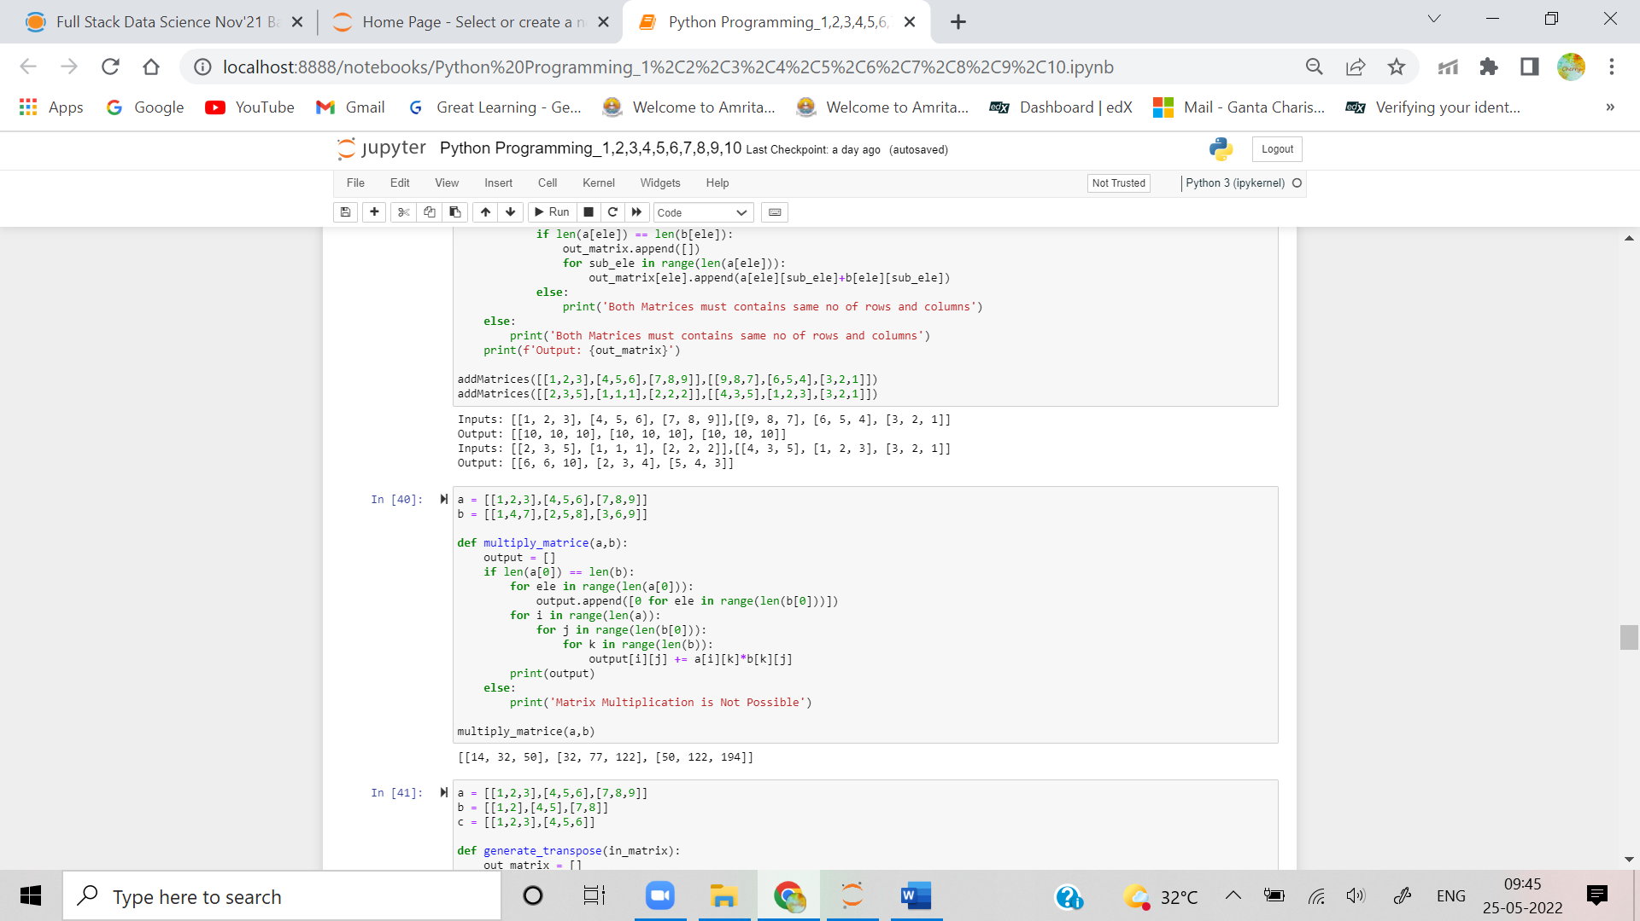

1. **Write a Python Program to Transpose a Matrix?**

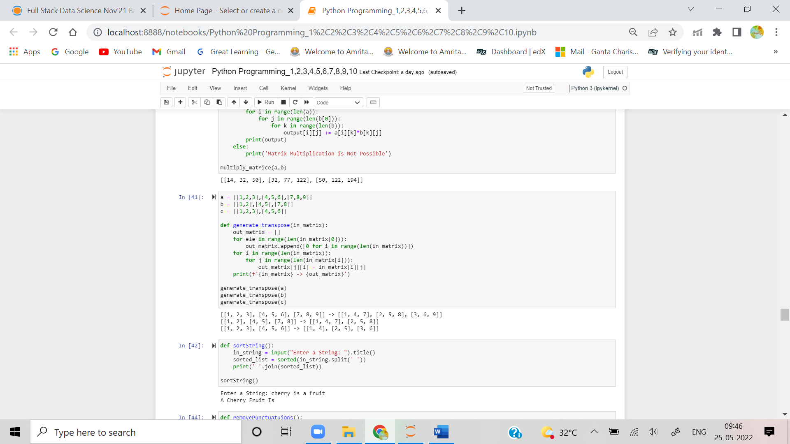

1. **Write a Python Program to Sort Words in Alphabetic Order?**

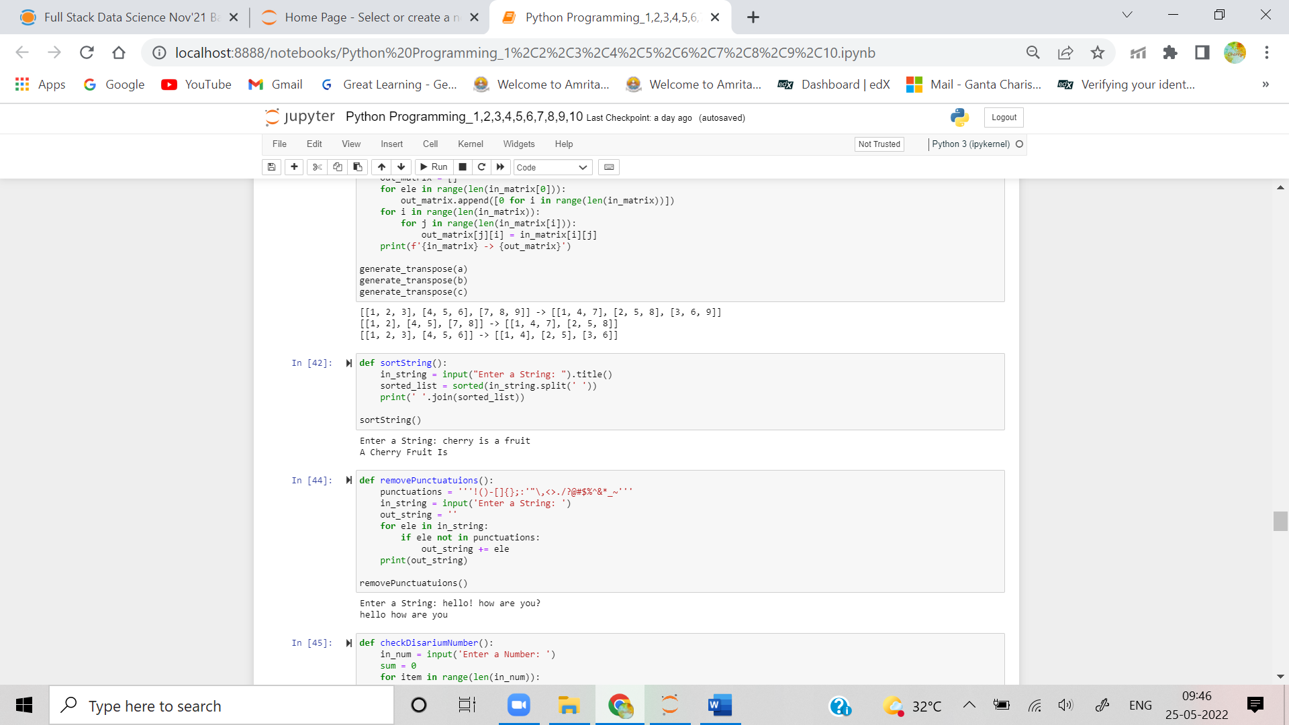

1. **Write a Python Program to Remove Punctuation From a String?**

